

**Western Australian Certificate of Education**

**ATAR course examination, 2019**

**Question/Answer Booklet**

12 PHYSICS

Name

**Test 4 - Induced EMF**

|  |  |  |  |  |  |  |  |  |  |  |
| --- | --- | --- | --- | --- | --- | --- | --- | --- | --- | --- |
| Student Number: In figures |  |  |  |  |  |  |  |  |  |  |

**Mark: $\frac{}{\text{40}}$**  In words

#### Time allowed for this paper

Reading time before commencing work: five minutes

Working time for paper: fifty minutes

**Materials required/recommended for this paper**

To be provided by the supervisor

This Question/Answer Booklet

Formulae and Data Booklet

***To be provided by the candidate***

Standard items: pens, (blue/black preferred), pencils (including coloured), sharpener, correction fluid/tape, eraser, ruler, highlighters

Special items: non-programmable calculators satisfying the conditions set by the School Curriculum and Standards Authority for this course

**Important note to candidates**

No other items may be taken into the examination room. It is your responsibility to ensure that you do not have any unauthorised notes or other items of a non-personal nature in the examination room. If you have any unauthorised material with you, hand it to the supervisor before reading any further.

**Structure of this paper**

|  |  |  |  |  |  |
| --- | --- | --- | --- | --- | --- |
| Section | Number of questions available | Number of questions to be answered | Suggested working time  (minutes) | Marks available | Percentage of exam |
| Section One:  Short Answers | 7 | 7 | 20 | 21 | 52 |
| Section Two:  Problem-solving | 3 | 3 | 30 | 19 | 48 |
| Section Three:  Comprehension | - | - | - | - | - |
|  |  |  |  | **Total** | 100 |

**Instructions to candidates**

1. The rules for the conduct of examinations at Holy Cross College are detailed in the College Examination Policy*.* Sitting this examination implies that you agree to abide by these rules.

2. Write your answers in this Question/Answer Booklet.

3. Working or reasoning should be clearly shown when calculating or estimating answers.

4. You must be careful to confine your responses to the specific questions asked and to follow any instructions that are specific to a particular question.

5. Spare pages are included at the end of this booklet. They can be used for planning your

responses and/or as additional space if required to continue an answer.

• Planning: If you use the spare pages for planning, indicate this clearly at the top of the page.

• Continuing an answer: If you need to use the space to continue an answer, indicate in the original answer space where the answer is continued, i.e. give the page number. Fill in the number of the question(s) that you are continuing to answer at the top of the page.

6. Answers to questions involving calculations should be ***evaluated and given in decimal***

***form*.** It is suggested that you quote all answers to ***three significant figures***, with the

exception of questions for which estimates are required. Despite an incorrect final result, credit may be obtained for method and working, providing these are ***clearly and legibly set out***.

7. Questions containing the instruction "estimate" may give insufficient numerical data for their solution. Students should provide appropriate figures to enable an approximate solution to be obtained. Give final answers to a maximum of two significant figures and include appropriate units where applicable.

8. Note that when an answer is a vector quantity, it must be given with magnitude and direction.

9. In all calculations, units must be consistent throughout your working.

**Section A: Short Answer**

Marks Allocated: 21 marks out of 40 total marks.

This section has 7 questions. Answer the questions in the spaces provided.

**Question 1**

A metal aircraft with a wing span of 42.0 m flies horizontally with a speed of 1.00 x 103 kmh–1 in a direction due east in a region where the vertical component of the flux density of the Earth’s magnetic field is 4.50 × 10-5 T.

1. Calculate the flux cut per second by the wings of the aircraft. **(2 marks)**
2. What would be the change in the potential difference, if any, if the aircraft flew due west?

**(1 mark)**

**Question 2**

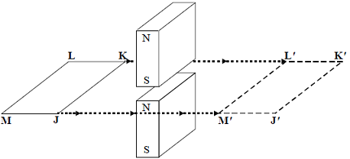

A rectangular conducting loop is pulled horizontally through the gap between two vertical magnets as shown in the diagram.

Which one of the graphs best represents the variation of loop current ***I*** with time ***t*** as the loop moves at a constant speed from **JKLM** to **J'K'L'M'**?

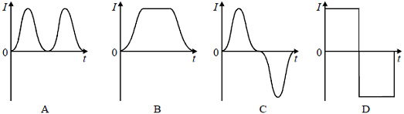

Answer: ________ **(1 mark)**

**Question 3**

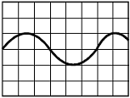

The diagram to the right shows the waveform obtained when the output of a generator is connected to a cathode ray oscilloscope.

Which one of the diagrams below best represents the output when the speed of rotation of the generator is ***doubled*** and no adjustment is made to the oscilloscope?

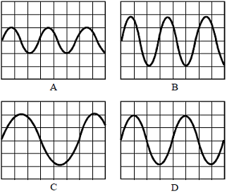

Answer: ____________ **(1 mark)**

**Question 4**

The graph shows how the flux linkage, *NΦ*, through a coil changes when the coil is moved into a magnetic field.

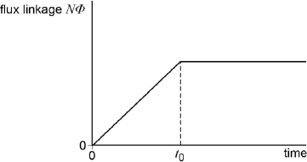

(a) The emf induced in the coil: **(1 mark)**

|  |  |  |
| --- | --- | --- |
| **A** | decreases, then becomes zero after time *t*0. |  |
| **B** | increases, then becomes constant after time *t*0. |  |
| **C** | is constant, then becomes zero after time *t*0. |  |
| **D** | is zero, then increases after time *t*0. |  |

(b) Explain your choice. **(2 marks)**

**Question 5**

The diagram below shows an AC generator consisting of a rectangular coil with sides 20.0 cm x 30.0 cm and 1000 turns rotating in a uniform magnetic field. The magnetic flux through the coil in the position shown is 3.00 x 10-4 Wb.



(a) What is the magnitude of the magnetic field between the magnets? **(2 marks)**

(b) The coil rotates at 50.0 Hz. Calculate the magnitude of the maximum induced EMF in the coil. (**2 marks)**

**Question 6**

(a) Describe and explain ***two*** features of the core that improve the efficiency of a transformer.

**(2 marks)**

(b) The primary coil of the transformer is connected to a 230 Vrms ac supply. The current in the primary coil is 0.300 Arms. The secondary coil has 300 turns and provides an output of

20.0 Vrms and a power of 65.0 W.

(i) Calculate the number of turns on the primary coil. **(1 mark)**

(ii) Calculate the efficiency of the transformer. **(2 marks)**

**Question 7**

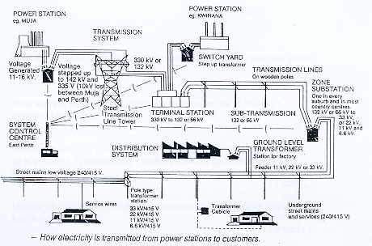

The diagram above shows the power transmission grid for the Perth region. The power is generated at a voltage of 11.0 – 16.0 kV, transmitted at 132 kV and supplied to houses and industry at 240 V or 415 V.

The demand for power in Perth can reach 1.80 x 103 MW during peak loadings.

Given that the resistance of the power lines from Muja to Perth (2.50 x 102 km away) is 5.00 Ω, calculate the ***percentage power loss,*** assuming it is transmitted at 330 kV.

**(4 marks)**

**Section B: Problem Solving**

Marks Allocated: 20 marks out of 41 total marks

This section has 3 questions. Answer the questions in the spaces provided.

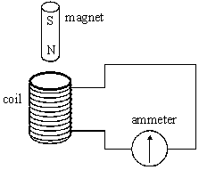**Question 8**

A coil is connected to a centre-zero ammeter, as shown. A student drops a magnet so that it falls vertically and completely through the coil.

(a)     Describe what the student would observe on the ammeter as the magnet falls through the coil. **(2 marks)**

(b)     If the coil were not present, the magnet would accelerate downwards at the acceleration due to gravity. State and explain how its acceleration in the student’s experiment would be affected, if at all, ***as it left the coil****.* **(2 marks)**

(c)     Suppose the student forgot to connect the ammeter to the coil, therefore leaving the circuit incomplete, before carrying out the experiment. Describe and explain what difference this would make to your conclusions in part (b). **(3 marks)**

**Question 9**

The figure below shows an end-view of a simple electrical generator. A rectangular coil is rotated in a uniform magnetic field with the axle at right angles to the field direction. When in the position shown in the figure below, the angle between the direction of the magnetic field and the normal to the plane of the coil is *θ*.

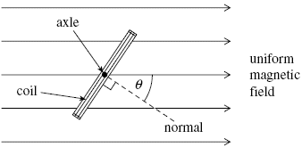

(a)     The coil has 50 turns and an area of 1.9 × 10–3 m2. The flux density of the magnetic field is 2.8 × 10–2 T. Calculate the ***flux linkage*** for the coil when *θ* is 35°, expressing your answer to an appropriate number of significant figures. **(3 marks)**

(b)     The coil is rotated at constant speed, causing an EMF to be induced.

(i)      Sketch a graph on the outline axes to show how the induced EMF varies with angle *θ* during one complete rotation of the coil, starting when *θ* = 0. Values are not required on the EMF axis of the graph. **(1 mark)**

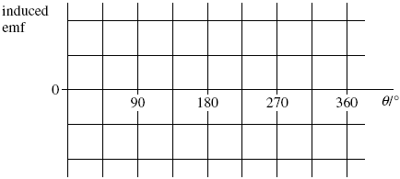

(ii)     Give the value of the flux threading the coil at the positions where the EMF has its greatest value. **(1 mark)**

(iii)     Explain why the magnitude of the EMF is greatest at the values of *θ* shown in your answer to part (b)(i). **(3 marks)**

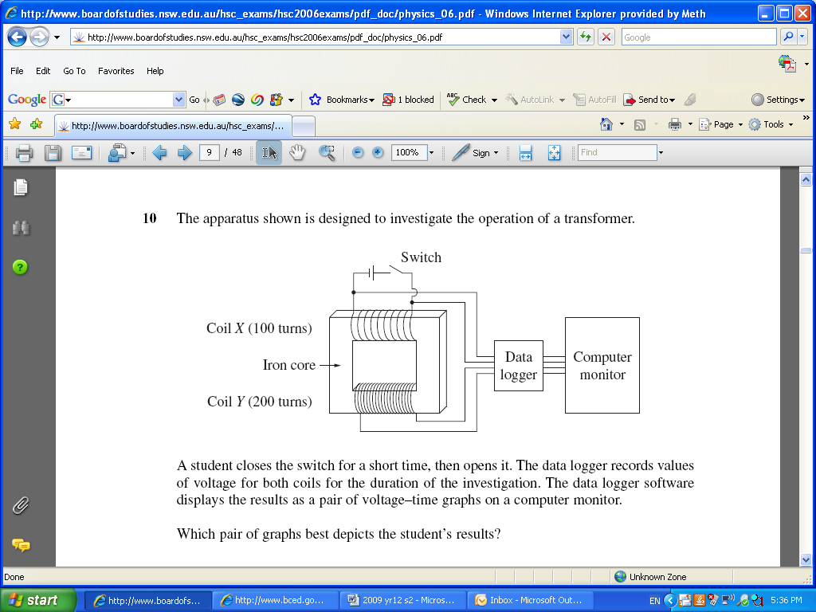**Question 10**

In a school experiment, students are constructing a transformer.

They set up the apparatus as shown in the diagram.

(a) While using the set up as shown in the diagram above, a student closes the switch for a short time, and then re-opens it. The data logger records the values for the voltage of both coil X and coil Y and displays it as voltage-time graphs.

Which of the following pairs of graphs best depicts the student’s results? **(1 mark)**

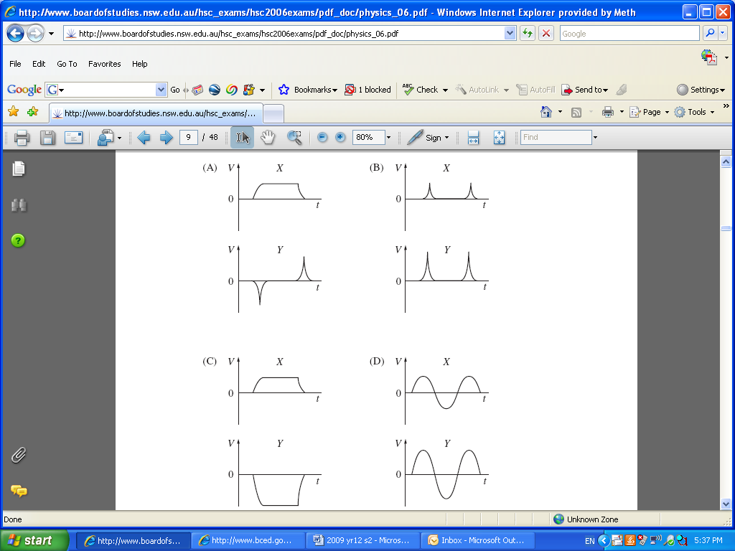

(b) The students realise that their ‘transformer’ is plugged into a DC power source and does not function correctly. The students change the input to an AC source and the transformer functions correctly. Explain why AC is necessary as an input current source for transformers. **(3 marks)**